

**A Novel Next-Generation Server Assistant Chatbot Using Machine Learning**

**MSc Computer Science**

Name**:**

ID

**Staffordshire University**

***A thesis submitted in partial fulfilment of the requirements of Staffordshire University for the degree of Master of Science***

May 2024

# Abstract

The Institution Helping Desk Chatbot automates student queries and facilitates institutional contact, a major achievement in educational technology. The chatbot uses NLP, machine learning computations, and web development to provide customers with instant access to academic schedules, enrollment, events, and various other college-related information. The technology uses user authentication to personalise interactions and secure data. The Flask web-based application interface lets students, instructors, and administrators communicate via the chatbot in many languages. Continuous improvement tactics adapt the chatbot to changing customer demands and technology, while rigorous verification and testing assure its correctness. Educational institutions may streamline administrative operations, improve user experience, and improve academic community contact with the Institution Helping Desk Chatbot.

# Acknowledgement

**Table of contents**

Abstract 2

Acknowledgement 2

1. Chapter One: Introduction 5

1.1 Introduction 5

1.2 Motivation 6

1.3 Aim 7

1.4 Objectives 7

1.5 Deliverables 7

1.6 Dissertation Structure 7

2. Chapter Two: Literature Review 9

2.1 Introduction 9

2.2 Digital Platform Through AI and NLP 10

2.3 Chatbot System using NLP 10

2.4 Deep Learning Campus Chat-Assistants Powered by AI Technology 11

2.5 An Intelligent Agent Is A Service-Bot (NLU And DL) Based Tool 12

2.6 Chatbot on the Current COVID-19 Situation 13

2.7 A Psychological Therapy Assisted Chatbot with Deep Learning Capability 13

2.8 Server Enquiry Chatbot 14

2.9 Intelligent Chatbot with NLP Capabilities to Support Learners 14

2.10 E-BANK CHATOT–Pleasant Dialogue with Consumers Using NLP 15

2.11 Question Answering-Based Chatbot Using Sequence to Sequence Model 15

2.12 Server Enquiry Chatbot Using Rasa Framework 16

2.13 Preventive Conversational System Evebot for Adolescent Emotional Well-being 16

2.14 Analysis of Problem / Improvement 18

3. Chapter Three: Research Methods 21

3.1 Introduction 21

3.2 Research Design 21

3.3 Research Specifications 22

3.3.1 Hardware Specifications 22

3.3.1 Software Specifications 23

3.4 Research Strategy 23

3.4.1 Data Collection and Analysis 23

3.4.2 Algorithm Development 24

3.4.3 Evaluation Methodologies 24

3.4.4 Iterative Refinement 24

3.4.5 Continuous Monitoring and Improvement 24

4. Chapter Four: Design of Artefact (4500 words total) 25

4.1 Introduction (200) 25

4.2 Design of the Artefact (1500 words) 25

4.3 Implementation (500 words) 25

4.4 Testing (400) 25

4.5 Validation (400) 25

4.6 Critical Evaluation (1500) 25

5. Chapter Five: Conclusion and Future Work (700 words) 25

5.1 Conclusion (400) 25

5.2 Future Work (300) 25

References 26

Appendices 27

Appendix (i): Project Link 27

Appendix (ii): Gantt Chart 27

**List of Figure**

**List of Tables**

# Chapter One: Introduction

## Introduction

This work is planned to build a chatbot, which is going to be using AI, and NLP and implemented using Python web application framework (Flask). This research project encourages chatbot comprehension and requests in natural languages with a high degree of accuracy due to using AI and NLP technology. This is a feature that enables the chatbot to answer the questions of the users individually, personalizing the information and exceeding the common, general replies traditional chatbots make.

The aim of this work is to improve the communication pathway between pupils and administration in order to coordinate query & feedback collection and ease the burden on staff. Members of the user population interact with the bot so that as it continually learns and applies up-to-date algorithms, the latter becomes more and more dynamic, in disposable and efficient. Technology is not separate from the framework as the latest technologies have been amalgamated in the Flask programming, which gives rise to trending interaction and interface methods, that support dynamic information retrieval.

The design process takes into account feedback and input from stakeholders, and user research. The development process is guided by making sure that the chatbot supports the domain-specific requirements, and meets the user's expectations. Data collection occurs in two stages: secondly, during the training phase, we will ensure that the chatbot understands, domain-, location-, and language-specific facts, events, and languages by selecting the relevant data periods to feed the system with. Another thing I consider is the fact that integrating conversational AI methods and NLP techniques into the model development process makes it possible to create comfortable communication and accurate language recognition for Flask app users. In addition to that, the inclusion and take-off of the chatbot are accomplished and fused with the Flask web framework as the means of adding the feature and ensuring scalability. Through the deployment of Flask's capabilities to provide a connection bridge between the system and the user, the project aims to create a chatbot solution that is very beneficial for the users and offers a unique experience. This research is based upon the widely known chatbot protocols and frameworks, like Flask’s ‘free of charge framework’ which later will guide the development and ensure following the industry standards. Synthesising them with stakeholder feedback and user research we expect to realize a chatbot system employing the best advances in technology that is intuitive and amenable to the multiple needs and perspectives of end-users.

## Motivation

This research is based on the necessity to boost the effectiveness of digital communication channels by using intelligent chatbots, especially in educational, therapeutic and customer service situations. As a result of the growth in demand for more competent and convenient information systems both on campus and online, these AI-powered solutions are set up as useful tools for improving the interaction of users and their satisfaction. The most important thing here is the integration of Machine Learning (ML) and Natural Language Processing (NLP) into these systems because it allows for a grasp of complicated queries on a more appropriate and applicable level.  
  
Additionally, it is derived from the possible role of the chatbot systems to solve the problem of inequality access at the time of information, where responses are directly delivered to the users and reduce the burden of workers. In the realm of therapeutic services like campus psychological services, the chatbots act as a primary support, by categorizing cases and perhaps contributing to the feelings’ good health of people. To enhance customer service, live chatbots equipped with domain information databases can collectively and equally dissipate banking and university-related types of queries. This directly helps to fast track the delivery of information therefore boosting the satisfaction levels in customers.

The emergence of such technologies is not without its complexities. The research is put in place to bridge the performance metrics gap, discover the effect of dataset quality and size, and improve natural language understanding. The project will as such set its sights on the factors that make chatbots smarter, more articulate, and capable of sensing human emotions and thus exercising flexibility in their responses. Thus, simultaneously enhancing user experience and making it easy to add AI in any aspect of living, service and education which is a crucial point.

## Aim

This project aims to develop a smart chatbot model by use of natural language processing (NLP) and artificial intelligence (AI) technology, it will be able to interpret user questions and provide precise answers that are way adapted to their needs.

## Objectives

* To Build a human-like chatbot that will have a connection with the server so the student-faculty and others will have the piece of information like fees, facilities, and semester schedules in one click.
* To Integrate NLP and AI for the chatbot facilities that enable it to understand input queries and answer them precisely and on an individual basis.
* To develop workflows integrating student-admin correspondence lines, mitigate workloads at the staff level and also improve the handling of inquiries more efficiently.

## Deliverables

* Natural Language Processing (NLP) and Artificial Intelligence (AI) capabilities: Applying AI linguistics and intelligent algorithms to understand customer questions and provide curated and targeted replies.
* Streamlined communication channels: A chatbot integration with existing communication tools linking servers to enhance efficiency in managing interactions.
* Enhanced user experience: Developing customer interfaces and productive conversations is to build the capability of the users to make conscious choices about their education.
* Comprehensive technical documentation: Providing detailed documentation about the system design, implementation, test and usability report which is the project's single contribution and verification document.

## Dissertation Structure

The rest of the dissertation presents a thorough introduction to the Literature Review which provides background information on the existing studies. In chapter three, the Research Methods applied are presented with attention to the frameworks which were used and techniques of analysis. Chapter Four “Developing the Chatbot Systems” explains the development path from design to the prototype until the final version of the bot. The chapter, Synthesis, Conclusions and Future Work, is my final chapter and it subjects my research findings to a critique as well as provides possible ways to work the system thus improving my field.

# Chapter Two: Literature Review

## Introduction

Today's digital environment, with technology integrated into every facet of human life, including communication, education, entertainment, and transportation, has witnessed massive progress in user interfaces in particular (Kulkarni, 2017). From the initial command for the text-based models to the famous GUI interfaces and, recently, the web-based options that are now available, the design of user interaction continues to improve to meet the wide range of needs of the users nevertheless, even though new technologies help people circumvent the states of inability to reach a vast amount of information effortlessly and intuitively, especially in such environments as educational institutions or in highly specialized domains, the problem of mismatching the system with the person attempting to use it persists (Pathania, 2020).

The expansion and digitalization of learning solutions in educational environments brought about by the widespread adoption of the Internet have shown that the user experience and the accessibility of learning platforms are a critical aspect. In the active circle of students, faculty, and other shareholders who desire to get things done faster and, on the go, there is a necessity for relevant technologies that can ease communication and make data retrieval smooth and efficient. Herein, we propose using chatbots as a new conversational user interface as a potentially successful approach (Ramesh, 2021).

Chatbots are a more thoughtful way of communicating with customers with the help of natural language processing (NLP) powered by artificial intelligence (AI) algorithms that bring in that lifelike conversation with humans. Using chatbots, educational institutions can put users' services at a personalized help desk, supply real-time information, and provide users with easy access to resources straight, improving users’ experience and satisfaction (Yin, 2019).

College websites are also known for being a source of both facts and some concerns. Building an intelligent chatbot model specifically for educational institutions is a good idea (Koubaa, 2023). This is an AI-powered colleague, able to interpret user questions, give correct answers, and smooth interactions between students, professors, and the university's administration. Integrating NLP and AI will enable the chatbot to provide smart replies when handling users’ inquiries, resulting in better service, efficiency, and ease of accessing information. Among the key objectives is to develop a chatbot with a human-like form, integrate NLP and AI for an appropriate enumeration process and design workflows that will process the communication system and ameliorate the management of the question (Shivashankar, 2021). The project will produce products that include NLP and AI assets, smoothened communications channels, a user-friendly environment, and comprehensive technical documentation.

## Digital Platform Through AI and NLP

The user interfaces used for software applications are mainly command line, graphical user interface (GUI), menu-driven, form-based, natural language, etc. A user interface is mainly GUI and web-based, whereas the need for an alternative user interface comes at other times. This space is naturally covered by combining machine learning with a chatbot-based conversational user interface. A sort of bot known as 'chatbots' exists within chat platforms (Nikhath, 2022). This can be done by using graphical interfaces and widgets, and the trend is being directed towards such ways. They usually act as a stateless service that does not hold the application session data. One of the first issues the student encounters on a college’s website is where to search for information. This complicates obtaining data on an employee or a student from a particular school. The problem is a college inquiry chatbot on a college website where one will get inquiries fast and interactively and have a standard and informative interface for user interface and reliable information to be passed over to the users. Chatbots are a modern technological system developed based on AI and NLP algorithms (Natural Language Processing). It has a simple user interface and finds answers to the needs of examination cells, admission, academics, students attendance records and grade point averages, placement cells and others. Recognition of needs is the main point (Lalwani, 2018).

## Chatbot System using NLP

Artificial intelligence (AI), a computer-based program implementing predetermined coding rules to display human language, is one of the types. It has multiple uses for which it is made, including working on electricity at home, acting as a personal virtual assistant, providing entertainment, telling answers to popular questions, and giving you driving instructions, among others. It is used by corporations mainly due to its ability to handle various customers simultaneously, thereby cutting customer service expenses. It takes much work to make the chatbots effective models for their purposes. (Giarnieri, 2023) created a chatbot FAQ to answer learners' questions about the college on the level of the educational process. The chatbot utilizes ML and NLP technology to provide accurate and concise answers about the institution quickly and efficiently (Verma, 2022).

In the chatbot industry, which is characterized by the development of technology, new and more friendly customer solutions are implemented. The recent approaches in chatbot generation are based on the reading about technologies where the Flask framework is among the tool bases (Koubaa, 2023). Flask, a framework well-known for its simplicity and adaptability, is a standard pick among devs when making small-scale but precisely performing bots that need to be integrated easily into the process and scaled up.

Artificial intelligence and natural language processing achievements of the latest AI technologies allow chatbots to interpret and act based on a user’s phrases. The study by Jain et al., which was conducted in 2023, (Meşe, 2023) depicts the power of placing AI systems at the front end of the chatbots to improve their ability to understand human language and after that make the conversations more natural and intuitive. Such integration experienced a change from simple rule-based systems to IBM’s super-AI, which can learn from each of the previous dialogues and thus progress over time.

Flask's contribution to Genesis was far more significant than is often recognized. As a lightweight web micro framework, it produces the required flexibility for developers to begin experimenting with the AI and NLP technologies, which could be fulfilled with the heavier frame networks. Its lightweight capability, therefore, becomes a critical feature for the flexible deployment of chatbots with intelligent conversations and handling complex interactions. (Sajja, 2023) argued that one of Flask's strengths was its friendliness with the different AI and NLP libraries that had been developed, such as TensorFlow and spaCy. This thus placed it in a position to easily create chatbots with high levels of language understanding capabilities.

## Deep Learning Campus Chat-Assistants Powered by AI Technology

With people now widely relying on the virtual space for quick and fast student support through a 24/7 service, there is quite an uptime for academic chatbots nowadays. Chatbot is an entity based on active behaviour imitation of human dialogical conversations. The project aims to introduce a chatbot for a college site that helps increase accessibility, reliability, and computer-human interaction quality. Campus navigation through Google Maps in the chatbot is also an extra feature that is included to aid the student with their search further (H, 2022). First, a menu is displayed covering the collocation of links, which consequently redirects a webpage if a user clicks on it. In adding artificial intelligence and deep learning technologies, a chatbot was developed to help EVA live a humanized life. The Natural Language Processing technique is employed for users to input the natural language, thus supporting the idea of dialoguing. A Model follows a Neural Network Sequence and uses the concept of a Bag of Words as a basis (G Khandagale, 2021).

There is one tool that is used to create the interface type called Tkinter. An efficiency rate of 89% was revealed through a typical performance test, a basis-level benchmark. Finally, the chatbot was infused into the background of a college website, and eventually, this functionality became a fluent college chatbot. The valuable ability of EVA has arisen from the fact that it isn't only capable of providing quick answers to the user’s queries. Still, it also links to information concerning course content, extracurricular activities or even directions to various locations on campus, according to the user's requirement (Shivashankar, 2021).

## An Intelligent Agent Is A Service-Bot (NLU And DL) Based Tool

Most of the best chatbot experiences built on Flask follow similar architectural approaches that promote modularity, scalability and ease of integrating with other systems. These projects often go with Flask to handle the web hosting aspects, and the chatbot, in turn, features elements of AI and NLP. For instance, the case study done by Lee and Kim shows that the use of cloud services by a chatbot built with the Flask framework makes it possible to scale and adapt to meeting the demands of the growing users, which reflects the flexibility capability of the Flask framework in chatbots development. Particularly, the requirement gathering is carefully elaborated since this makes the foundation of the design. The definition of users and stakeholders to ensure the chatbot is tailored to suit the individual needs of the target audience takes place during the initial stage of the development process. This step involves establishing functionalities, understanding specific communication for each domain, and sketching screens' interaction flows. The study done by (Koundinya, 2020) revealed that this is the essential step of the product development process, being a sine qua non condition of a product that is interesting, engaging and has excellent reviews from the users (Ramesh, 2021).

Both data collection and model stand together as critical procedures in creating a Flask-based chatbot. The (Khin.T, 2020) shows that the best method of training chatbots is one of two approaches. The first emphasizes using pre-existing datasets. Another approach generates custom data that are exclusive to the given use case. There are so many possibilities as to the kind of data that will be meaningful in the chatbot’s quest to understand and reply to inputs accurately. The modelling process entails selecting the most suitable NLP and AI tricks to treat and interpret user input. As clarified by (Ranoliya, 2017), the addition of NLP modules, which play well with Flask, is for two critical reasons—they bring about not only NLU but also enable the creation of system responses as fast as possible, which has been helping users to interact with the system smoothly.

Every year, users hit the Check website to put their questions at ease. Along with them, the students also look for solutions and follow the instructions on that website (AN Mathew, 2021). The chatbot, deemed as ‘an Intelligent Enquiry Bot’, became one platform for interested applicants. A BU remains intelligent enough to tackle the needs of different stakeholder types like freshers, parents, students and faculty. The college drill chatbot has been designed with the help of specific algorithms that reply to queries. The Module is referred to as an internet application with the ability to provide responses to user queries depending on the employed natural language process as well as the long-term memories (LSTMs), which are a particular type of Deep Neural Network (DNN). In this work, we have just developed a chatbot that uses NLP and DNN for questions of college time and helps new students, especially those who choose their programme to join (Wong, 2022).

## Chatbot on the Current COVID-19 Situation

Not only in recent years, but we’ve also pretty much implemented many different chatbot practices. "Chatbot" is a familiar assistant that understands and responds in a human-like language. While some chatbots go commercial and thousands of people already use their services, a massive amount of data necessary for creating a data-driven system is still a problem in development. The following paper outlines a few genuine agents developed with Python, where natural expressions bring about agents' actions. Apart from this, accessibility through web integration is also given to examine the chatbot on a web-based platform, thus assisting in improving the human-human interaction (Pillai, 2023).

## A Psychological Therapy Assisted Chatbot with Deep Learning Capability

Listening agents have been exposed to diverse user-speaking styles for the past several years. Chatbot is based on conventional agents that interact with operators in a friendly, fluid manner. Many chatbot platforms already exist, but there are challenges to building data-driven systems on them due to the high amount of data needed to develop them. This paper would be the critical element of providing various such agents along with natural expressions expressed in Python. Furthermore, to provide a holistic experience, the internet connection is also integrated, which will aid in evaluating the chatbot on a web-based platform and offer analysis regarding human-chatbot interactions. (Meşe, 2023).

## Server Enquiry Chatbot

In this paper, we aim to apply a fully generative conversational diagnosis system called Evebot, which is based on a context-sensitive sequence-to-sequence model. This system will be able to identify negative emotions and prevent depression by generating positive suggestions. As for the system itself, its architecture is based on the collection of deep-learning models, such as the Bi-LSTM-based model (Huang, 2023). This model is designed to detect negative sentiments expressed by users and gather a corpus of psychological counselling sentences that are to be used for chatbot training. Besides, there is the language sequence to sequence neural networks and the MMI model. The problem with young people is that they are expressing their negative emotions to others and digital interactions. The emotion analysis and comforting methods used in physical meetings may need to be more convenient. Thus, this approach draws particular attention to the application of virtual platforms for noticing depression or anxiety signs, directing the mood and stress of teenagers, and thereby suppressing the appearance of mental disorders. The smart dispensing system chatbot, being integrated, was introduced to an online platform user-testing population that underwent real-world campus trials. Forming the basis of this research, it could collect more favourable data regarding the rise in positivity than recently designed public chatbots on a comparison basis ((Nikhath)).G.Pathania. Tamil, also known as Dravidian, is a language spoken in the southeastern part of India in states such as Tamil Nadu, Karnataka, Andhra Pradesh, and Kerala.

## Intelligent Chatbot with NLP Capabilities to Support Learners

The fast spread of COVID-19 showed up on the Earth in 2020-2021, and a few months later, Ninchat offered a new phase of its product line and powered up its products with even more features. Because of this, the whole essence of this task was to create a reliable, functional chatbot for existing and potential customers (AN Mathew, 2021). All the product's attributes should be considered during the development process. Among them, the maintenance procedure should be simple, and the scalability option should be available to integrate the new feature seamlessly with Ninchat's current infrastructure. Authors will go through the most accessible solutions and utilise WebAssembly as the structure to fit the designed product in the present thesis. Finally, the interfaces were determined, and the product was assessed based on technical and business criteria. Finally, the practical exit of the thesis helped to produce a usable product (Sajja, 2023). Finally, the project result can improve a person’s practical knowledge and skills and be useful to other researchers with the same purpose.

## E-BANK CHATOT–Pleasant Dialogue with Consumers Using NLP

The perfect scenario would be when the instructor can tackle everyone's concerns separately. However, this cannot be fulfilled insomuch as teachers have little time, and they may also end up being drained at the end of long periods of consultation (G Khandagale, 2021). Chatbots are an excellent option to tackle this opposing household in the first stage of testing on Feb 11, 2019, 27 students with access to the conversational agent prototype built by the author were involved. The students compared the chatbot and a quiz website. The academic content provided by the chatbot is the same as the website. Over 80% of the students agreed that the chatbot is better than the quiz website in many aspects. However, about half of the students indicated that the chatbot took them more time to complete the quiz than the website. The author proposed using the Unified Theory of Acceptance and Use of Technology (UTAUT) framework to conduct more research into this area. The knowledge would allow more teachers to create chatbots in more disciplines of study so that students are more motivated to achieve better learning outcomes (Koundinya, 2020).

## Question Answering-Based Chatbot Using Sequence to Sequence Model

Chatbots are intelligent systems that understand users’ natural language queries and respond accordingly in a conversation, which is the focus of this study. It is more like a virtual assistant; people feel like talking with a natural person. They speak the same language we do and can answer questions. Humans are insufficient in banks, customer care centres and enquiry desks. Usually, he takes a long time to process a single request, which wastes time and reduces the quality of customer service (Lalwani, 2018). The primary goal of this chatbot is for the customer to interact by mentioning their queries in plain English, and the chatbot can resolve their queries with appropriate responses in return. The proposed system would help replicate the customer service experience with one difference: the customer would interact with a bot instead of a natural person and yet get the queries attended to and resolved. It can extend daily life by providing solutions to help desks, telephone answering systems, and customer care centres. This paper explains the dataset that we have prepared from FAQs of banks' websites, as well as the architecture and methodology used for developing such chatbots. This paper also compares seven classification algorithms used to get the class of input to the chatbot (Lalwani, 2018).

## Server Enquiry Chatbot Using Rasa Framework

Educational chatbots have great potential to help students, teachers and education staff. They provide useful information in educational sectors for inquirers. Neural chatbots are more scalable and popular than earlier ruled-based chatbots. Recurrent Neural Network based Sequence to Sequence (Seq2Seq) model can be used to create chatbots. Seq2Seq is adapted for an excellent sequence conversational model, especially in question-answering systems. In this paper, we explore the ways of communication through neural network chatbots by using the Sequence model with an Attention Mechanism based on the RNN encoder-decoder model. This chatbot is intended to be used in the university education sector to answer frequently asked questions about the university and its related information. It is the first Myanmar Language University Chatbot to use a neural network model and gets a 0.41 BLEU score (Ramesh, 2021).

## Preventive Conversational System Evebot for Adolescent Emotional Well-being

Top of Form

In this paper, we propose Evebot, an innovative, sequence-to-sequence (Seq2seq) based, fully generative conversational system for diagnosing negative emotions and preventing depression through positively suggestive responses. The system consists of an assembly of deep-learning-based models, including a Bi-LSTM-based model for detecting negative emotions of users and obtaining psychological counselling-related corpus for training the chatbot, anti-language sequence to sequence neural network, and maximum mutual information (MMI) model (Nikhath, 2022). As adolescents are reluctant to show their negative emotions in physical interaction, traditional methods of emotion analysis and comforting methods may not work. Therefore, this system emphasizes using virtual platforms to detect signs of depression or anxiety, channel adolescents' stress and mood, and thus prevent the emergence of mental illness. We launched the integrated chatbot system onto an online platform for real-world campus applications. Through a one-month user study, we observe better results in the increase in positivity than other public chatbots in the control group (Wong, 2022).

In conclusion, the literature review on the chatologies that are based on the flask technology involves immersion, deployment, evaluation, and rework. Successful implementation needs intelligent design of scalability and the aspect of feature inclusivity, which will enable the robot to handle real-world scenarios. Assessment, previous-output-based development, and feedback provide the opportunity to develop the chatbot in future; as mentioned in the article by Field (Hasan, 2023), the authors emphasize the importance of doing the above to make the chatbot relevant to the users and their taste. Flask-centred chatbot literature describes the ways and means of developing robust and user-friendly chatbot applications. Through the use of Flask for its advantage of the advanced ability to integrate AI and NLP, the developers will be able to create chatbots that offer user experience with enhanced features such as personalized and intuitive interactions. The future is full of promise as the area continues to be the subject of intensified research trials and discoveries.

Table 1: Literature Review Findings

|  |  |  |  |  |  |
| --- | --- | --- | --- | --- | --- |
| **Study** | **Year** | **Dataset** | **Performance** | **Pros** | **Cons** |
| University Chatbot System using NLP | 2022 | Not Available | Not Available | Uses ML and NLP for precise responses | Additional details on improvement areas not provided |
| Deep Learning based Campus Assistive Chatbot | 2021 | Not Available | 89% efficiency | Integrates campus navigation, provides concise answers | Specific performance metrics beyond efficiency rate not mentioned |
| An Intelligent Server Enquiry Bot using NLP and Deep Learning | 2021 | Not Available | Not Available | Utilizes NLP and LSTM for query handling | Specific cons not mentioned |
| Chatbot for server website | 2020 | Not Available | Not Available | Enhances Human-Chatbot interactions | Development requires significant data |
| A deep learning based chatbot for campus psychological therapy | 2021 | Not Available | Not Available | Targets campus psychological therapy | Challenges in data-driven system development |
| Server Enquiry Chat Bot | 2020 | Not Available | Not Available | Focuses on emotional diagnosis and depression prevention | Emphasis on virtual interaction may not suit all situations |
| The Design of an Intelligent Chatbot with NLP Capabilities | 2021 | Not Available | Not Available | Aims to enhance digital communication products | Specific cons not detailed |
| BANK CHAT BOT–an intelligent assistant system | 2020 | Not Available | Not Available | Provides an alternative to traditional learning methods | Some users found it slower compared to alternative methods |
| Question answering based university chatbot | 2018 | FAQs from banks websites | Not Available | Aims to improve customer service efficiency | Specific performance metrics not provided |
| Server enquiry chatbot using rasa framework | 2021 | Not Available | 0.41 BLEU score | The first Myanmar Language University Chatbot using neural network | Language-specific; performance indicates potential for improvement |
| Preventive Conversational System Evebot | 2022 | Not Available | Observed increase in positivity | Targets adolescent emotional well-being through a virtual platform | Limited study duration; long-term effectiveness not established |

Table 1. provides the whole review of different chatbots’ development from 2018 to 2023 with an emphasis on their university application, campus navigation, server inquiry, psychological therapy and banking. Absence of details about the exact dataset or performance metrics for the rest of the projects, however, there is a Deep Learning-based Campus Assistive chatbot from 2021, an 89% high-efficiency-rate program. A great part here includes ML and NLP methods whose aim is to support the interaction by users with better quality and a high level of understanding; also, there is a handling of the special cases. Striking issues are, on the other hand, a deficiency of the concept behind measures, lacking route evaluation indicators, and lastly, that of drawing information from the field. The server inquiry chatbot, which applied the rasa framework as the technology, was the first NLP with language style set as the Myanmar Language, which was using deep learning framework and it showed room for improvement with the 0.41 BLEU score. In this respect, the examples above show how different AI technologies is innervating many campus and online services and although most of them lack detailed evaluation metrics and face development challenges, AI technology is unignorable in service provision

## Analysis of Problem / Improvement

The study of the problem and potential improvements in the manufacturing of chatbots using machine learning is greatly dependent on the finding of some literature. The presented results are of the literature review of chatbot systems, their efficiency indicators as well as strengths and disadvantages. Researchers can discover ways and opportunities on how their chatbot project can be improved or innovated by integrating such learnings. Among the reviewed literature, a leading trend is a widespread opinion that machine learning (ML) and natural language processing (NLP) are key technologies in chatbot development. On the other hand, however, an investigation on the current state of AI facilitated by the University Chatbot System in 2022 involved AI by leveraging ML and NLP to precisely offer responses. Moreover, the same Intelligent Server Enquiry Bot employed Natural Language Processing (NLP) and LSTM for query handling in the same year of 2021. This method mirrors the advantage of ML and NLP in enhancing chatbot competence, especially, in the area of comprehending as well as producing natural language responses.

The implementation of modern technologies may be criticized in some aspects by the experts. Another limitation has to do with not having any particular performance measures beyond such high rates of efficiency. As an illustration, what is provided is not the efficiency value but the percentage, that is, 89%, of the Campus Assistive Chatbot according to the Deep Learning and there is no detailed performance statistic. This consequence in the barrier to knowing the chatbot's best features as well as its flaws, so it becomes difficult to discover the exact areas in which improvement can be made. Some studies show that data accessibility and quality are key to issues. The development of humanoid robots, for instance, the Chatbot for Server Website in 2020, often needs big data collection which is usually a critical task. Obtaining and understanding this data is both valuable and technologically demanding, which can slow down the speed of systems’ deployment and scale operation.

One more issue that is frequently raised is the suitability of chatbots in the diverse contexts of the real world and the variety of user demographics. Instances abound that where like the Human Enquiry Chat Assistance block of 2020 focus on depression prevention and emotional diagnosis. The virtual interaction might not fit all situations or all users. What’s more, narrowly language-specific chatbots, like the Rasa framework-based Server Enquiry Chatbot in 2021, encounter difficulties in reaching widespread popularity, that is, to be of use for broad audiences beyond such linguistic communities. Besides, the effectiveness and durability of the chatbots having an impact on customer outcomes remain the field of further study. Such research as Preventive Conversational System Evebot from 2022, for example, did report an increase in users’ positivity; nevertheless, a cross-cutting comprehensive study of this phenomenon over the long term was not and still not conducted and, consequently, might not be effective in addressing the complex psychological issues, like emotional difficulties of the adolescents.

Although the literature offers meaningful insights into the development and implementation of a chatbot system, further developments should be carried out to create the next-generation server assistant chatbot. These include modifying other performance metrics for collective assessment, addressing data problems, speeding up adaptation across diverse settings, and studying the consequences of long-term outcomes in users. The solution to these issues will make chatbot technology more advanced and ensure user-friendly and better products.

# Chapter Three: Research Methods

## Introduction

The chapter shows an important stage in the development of the area of educational technologies, providing a unique way in which educational institutions. This chapter includes research design, research approach, and requirements specifications such as hardware and software, it also presents the development tools justification and data collection methods.

This web-based chatbot system is designed to revolutionize user interactions in the educational domain. This cutting-edge system harnesses the power of artificial intelligence (AI) to facilitate seamless communication between users and educational institutions. Unlike traditional inquiry methods, which often involve cumbersome processes and time-consuming interactions, the chatbot streamlines the information-seeking experience by providing instant responses to user queries.

By leveraging AI algorithms, the chatbot system is capable of understanding natural language inputs and generating contextually relevant responses. This advanced functionality enables users, including students and parents, to obtain timely information about various college-related activities without the need for direct human intervention. Whether seeking details about admissions, course offerings, or campus events, users can simply input their queries into the chatbot interface and receive accurate and informative responses in real time.

## Research Design

The chatbot system design research represents a systematic approach to creating and constructing an intelligent interface for establishing a chat session which can address user queries competently. The architecture of this design involves several core elements such as data collection, system framework, algorithm development and evaluation procedures. The investigation will focus on data associated with user queries, preferences, and interaction behaviours which are collected in stage one. This stage is about learning what they want by looking at feedback from future users, including students and their parents, to meet their needs and fulfil their expectations. Furthermore, existing knowledge bases, as well as repositories, are also taken into consideration for effective reinforcement of the chatbot’s capability of answering questions of the users adequately.

Reflected in the system architecture designed due to the data that was collected in the data collection phase, is the smooth integration of the users with the chatbot, which is one of the major aspects. This comprises making a selection of the technology stack and matching relevant programming languages, frameworks, and APIs to build up the chatbot's main functionality. The architecture has to be able to process and understand natural language script (NLP) by responding to user queries and providing adequate information to them.

I am utilising NLP techniques to add value to these algorithms; allowing them to understand the meaning of the intended user input and draw precise information. Thereby, machine learning algorithms such as trained iteratively on user interaction data, may be employed to help identify user purpose and context.

The proposed chatbot system passes an extensive test period to test its resilience and capability of correctly answering users' queries. Assessment mechanisms may comprise user-run testing, in which users use the chatbot in a controlled environment with specific aims to determine the usability issues and user experience challenges. Besides, the system's correctness and response quality are considered through a benchmark against a toolkit of test cases and successful user feedback.

Different issues found out during the evaluation phase are taken care of and the chatbot gets some iterative rearrangements to enhance its performance. This might include conducting a process of updating the system's algorithms, routinely adding to the system's knowledge base, or continuously working on improving the user interface base of experience and usability tests. This is where the experimental refinement process begins to perform until the chatbot system reaches satisfactory performance and user expectations levels.

## Research Specifications

### Hardware Specifications

**Server Infrastructure**

To set up a server that will run the chatbot software well and cater for concurrent user needs without compromising on quality. This is done through the two platforms, i.e., cloud servers or dedicated hosting servers.

**Processing Power**

The computational requirements of natural language processing (NLP) algorithms and machine learning models used by implementing a chatbot system.

**Storage Capacity**

To deliver sufficient storage regarding user data, chat history, and knowledge base to use for the chatbot. Use scalable data storage facilities in a way that data volume can be adjusted as necessary in the event of a future rise in data volumes over time.

### Software Specifications

**Programming Languages**

Programming languages like Python and JavaScript have been used to build backend as well as frontend development for designing chatbot applications.

**Frameworks and Libraries**

The frameworks and libraries such as Flask or Django for backend development, and React and Angular for frontend development become handy tools for developers and increase the code efficiency of this project.

**Natural Language Processing (NLP) Tools**

To incorporate NLP toolkits and libraries like NLTK (Natural Language Toolkit) or spaCy to enable the conversation system to understand natural language and process the user’s input.

**Machine Learning Libraries**

To employ machine learning libraries like TensorFlow and PyTorch for the creation and training of supervised learning models that enhance the understanding and response generation ability of the machine learning chatbot.

**Database Management System (DBMS)**

To use an effective DBMS platform like MySQL to store, manage and secure user data, chat histories and chatbot’s knowledge database as best as possible.

**Web Server**

To install and configure a chatbot application to communicate with the backend system via a web server Apache. Is used.

## Research Strategy

### Data Collection and Analysis

Collect data in this way concerning inquiries, preferences and application patterns which will enrich the development of the system. Conjunct these databases and repositories with the chatbot knowledge to enhance its aptness in responding accurately.

### Algorithm Development

Algorithms for processing queries from users that generate answers, deploying NLP algorithms to identify structural and semantic properties and mine for the particular information. I use technologies of machine learning algorithms to make the chatbot intelligible in deciphering the user's goal and where it comes from through repetitive training on user dialogue data.

### Evaluation Methodologies

To perform usability testing to find out usability matters and user interaction problems through directing effective techniques. I evaluate the system's accuracy and response quality by referencing test cases and user feedback targeting predefined parameters.

### Iterative Refinement

To ensure the quality evaluation from the last stage, refining the chatbot system accordingly to correct the problems that were revealed during the evaluation period, and improving its performance.

### Continuous Monitoring and Improvement

I monitor the chatbot performance and user satisfaction from one day to another, to help pinpoint what needs to be changed or needs to be improved. Continuous optimization related to the continual appraisal of the system becomes a must to achieve high quality of the performance criteria and consumers’ requirements.

# Chapter Four: Design of Artefact

## Introduction

The Institute's procedures for Assistance Desk Chatbot's invention, testing, authorization, and critical assessment are covered in this chapter. This chapter builds on previous chapters to develop the Python web application's virtual assistant.

Chatbots employ NLP, data integration, user authentication, and UI design. We describe architectural choices and component building methods to build the chatbot system.

The chatbot's structure and functioning are explained. Install Flask, integrate NLP, authenticate consumers, and attach to the database. Detailed explanations and methods teach implementation-related software engineering and coding concepts.

Chatbot dependability and efficacy require testing. We assess the chatbot's accuracy, efficiency, and the natural language processing engine's models for prediction through rigorous testing. Finally, we critically assess execution, testing, and validation to improve chatbot features and usability.

## Design of the Artefact

Establishing a successful Institute Help Desk Chatbot integration includes authentication, conversational assessment, and Flask web application deployment. This careful design ensures that the chatbot operates correctly and provides current and pertinent information.

**Architecture and system design first**

The Institute Service Desk Chatbot streamlines communication and information retrieval. The automated system addresses college and student administrative queries.

**Module for User/Admin Login**

The chatbot protects student, teacher, and college authority logins. For personalised engagement and data safety, users log in using username and password. After logging in, users can choose English, Hindi, and Marathi, improving usability.

The administrator can view query logs, edit replies, and add data. The correctness and usefulness of chatbot information depend on this.

**NLP Engine**

At the heart of the chatbots is a powerful NLP engine that interprets user intent and processes inquiries and instructions. This engine analyses text, identifies important phrases, and classifies questions into database-stored intents using complex algorithms and models like the previously proven Random Forest model.

Users may communicate spontaneously without a predefined inquiry style due to the chatbot's conversation flow. To understand and react to complicated questions, the chatbot uses cutting-edge NLP techniques including the use of tokenization and lemmatization.

**Flow chart**

The workflow of the chatbot depicted above could serve as a and provide a quick and easy help desk for individuals with mental health concerns. The user talks to the chatbot by entering a worldwide web message; the system processes it with the aim of understanding the intent. The intent recognition is formulated by defining the patterns already set in a JSON file which connects each pattern to a tag showing the requisite intent which could be the general greeting, admissions or events.

Once the purpose is known, the chat bot then will retrieve a predefined response that is stored in the same JSON file and which matches the purpose of the conversion recognized. Then, it goes to the user and is displayed. This way the chatbot not only will be able to handle substantial traffic of similar queries fast and accurately, but also will demonstrate the capability of differentiating user questions into specific intents and supplying exactly what the user is looking for.

Movement from here onward, creates a flowchart showing the operational flow of this chatbot in a visual way. This will, thus, help better the understanding of how the process works from receiving user input until the necessary amendments have been integrated and the response delivered.

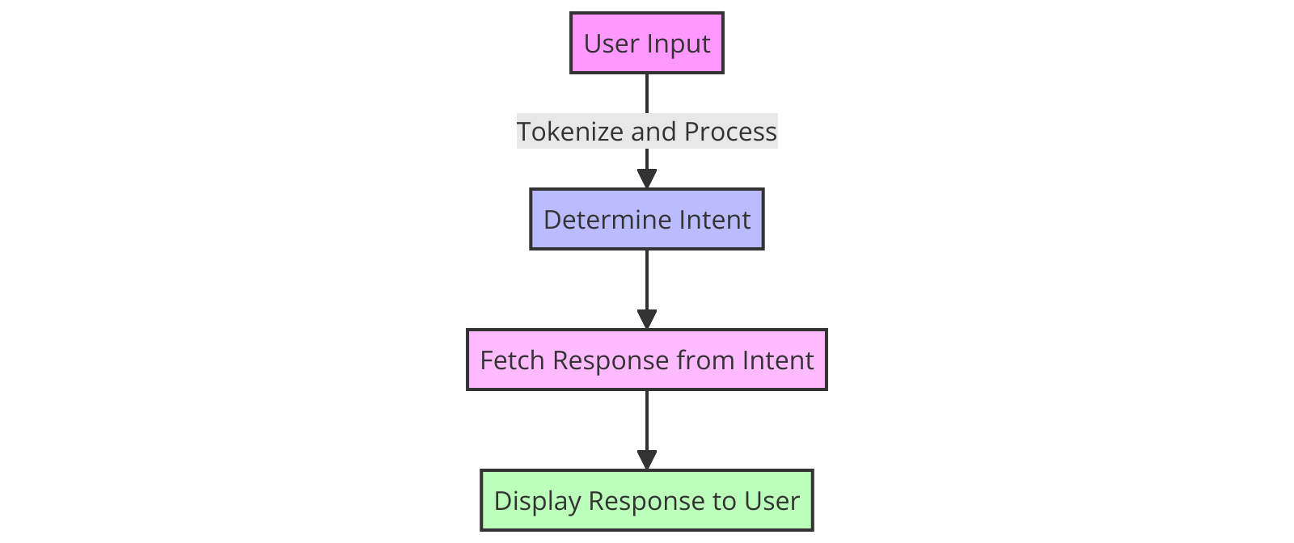

Figure 1 flow chart

**Database Integration**

The chatbot is supported by a large database of college-related information, including academic timetables, event details, enrollment, fees, and scholarships. When a query comes in, the chatbot scans the database for a response. Any new or changed query that is not in the database's records is reported as invalid and sent to a supervisor for examination and possible database insertion.

**Machine learning model Development**

In modeling of a chatbot using various types of machine learning can very much empower it to comprehend and answer user questions very well. Each one carries its unique value to the table, providing the necessary basis for language processing, comprehension, and overall decision-making.

The Logistic Regression model is one of the typical machine learning models that are usually used in the binary classification tasks. For a chatbot, it is possible to apply Logistic Regression due to this capability of the method to understand user intent by classifying given inputs into some pre-specified categories, such as 'information request', 'service request', 'complaint', etc. It works best when more linearly separable features are present and if the training is carried out with the large dataset of the labeled user queries with the help of their text representations

Not only is the multinomial naive bayes especially suitable for text classification due to its assumption of attribute-independence, but it also makes this algorithm more applicable for text classification tasks. The approach is appropriate for a chatbot process working with text data which classifies the text to the categories with the largest probability their word frequencies are connected. Whether through vector or tree space, it is algorithmically efficient and functional over large data sets. The model is trained with the tagged corpus, containing the phrases with proper attach labels, and this helps a model to learn whether words are likely given specific intent.

LSVC (Linear SVC) or Support Vector Classifier, a classifier specially created for binary and multiclass classification tasks, is on the other hand. When it comes to Linear SVCs, the structure is beneficial in ways that differentiate between diverse user intentions and compositions even in high-dimensional space, by maximizing the distance between classes. This model can be trained on vector text data that can even be enhanced with n-grams. Hence, it produces a very clear discrimination between various user queries.

Decision Tree is an approach that applies the tree-like flowchart with the purpose of showing every possible consequence of a decision. It simple and it tends to be visualized, so this approach can be used to explain how the decisions are made while chatting with the bot. In training, a Decision Tree will rely on features identified from the text in order to perform a repeated splitting process that intends to deliver similar queries in a same group and disperse different types of questions or requests among the users.

It becomes crucial for these models to be train that require a dataset rich enough to take different human conversations into account. Each model envisages tokenization, defuising, and vectorization of text as stages that are initial and ultimate. The training process focusses on parameter adjustments (e.g., learning rates, kernel functions for SVM, and depth of trees for decision trees). Finally, trained models are embedded into the chatbot’s backend integrity, where they interacts to interpret user inputs and compose adequately relevant response. All of models also brings something to the table as such the chatbot is able to be more reliable and effective showing human behavior.

**Deployment and UI**

Flask is used to deploy and interact with the chatbot. The lightweight and versatile Flask framework facilitates the development of websites with substantial capabilities.

**Setting up Flask Web App**

The Flask chatbot front end handles HTTP requests and displays the conversation UI. User sessions are managed by the app, guaranteeing personalised and secure interactions.

Navigation and interaction are simple with the chat interface, which requires minimal technological skills. It's responsive, ready for every device or screen size.

**Interaction Handling**

After Flask launches, users may type their questions into the user interface for chat to communicate with the chatbot. The application sends questions to the NLP engines, what operations them and retrieves database responses. Flask displays replies to users.

The technology effectively manages sessions, enabling ongoing chats and contextually relevant replies. Error management techniques handle unexpected inputs and system failures, making the chatbot more resilient.

**Continuous Testing and Improvement**

The system is rigorously tested for functionality, accuracy, & security before implementation. This involves unit, integration, and user acceptability testing by developers and a limited group of genuine users.

System feedback systems capture user experiences and recommendations. This input helps the chatbot adapt to user wants and technology.

The Institute Assistance Chatbot uses powerful NLP, secure authentication of users, and a user-friendly online application to improve educational institution communication. The chatbot automates regular requests, reducing administrative effort and improving the user experience, which makes it essential for modern education.

## Implementation

Implementing Institute Assistance Chatbot required several stages to be effective and user-friendly. It started with installing NLTK for spoken language the process, scikit-learn for machine learning, and Firebase for authentication for users. Pattern matching intents were recorded in 'intents.json', the chatbot's knowledge base.

**Preprocessing data**

The first critical step was data preparation, where synonym replacement enriched the dataset. This strategy increased training examples, helping the chatbot understand user inquiries. Following dataset enhancement, text data and labels had been separated and vectorized using TF-IDF. This turned text input into numerical characteristics for machine learning models.

**Selecting and Training Models**

Project then went to model selection. Logistic Regression, Multinomial Bayes, Naive Bayes, Linear SVC, a decision tree, and Random Forest were tested. GridSearchCV improved hyperparameter tuning by picking the best model based on validation set accuracy ratings. To guarantee robust performance, the ideal models was developed on the full dataset.

In the evaluation of machine learning models for an Institute help desk chatbot, various algorithms were compared based on accuracy. Logistic Regression, Multinomial Naive Bayes, Linear SVC, Decision Tree, and Random Forest models underwent validation using specific hyperparameters. The Random Forest model emerged as the best with an accuracy of 97.26%, using parameters like unlimited maximum depth, one minimum sample leaf, and two minimum samples split, along with 300 estimators. This demonstrates its robustness and suitability for handling diverse user queries in a help desk scenario, providing reliable predictions and effectively understanding user intents.

**Flask web app deployment**

The model was deployed into real time using a Flask web-based application after training. The Flask app's user-friendly UI lets users input queries to the chatbot. The trained model-powered chatbot would evaluate these inputs, estimate the intent, and respond using predetermined intent answers.

**Authentication and Security**

The Figures 2,3,4 show the login and signup screens of a web application that utilizes Firebase for user authentication. This design is part of a security measure to ensure that access to the chatbot is gated and secure, allowing only authenticated users to proceed to the dashboard. The login screen is straightforward, requiring users to enter their email and password to gain access. This simplicity ensures a smooth user experience while maintaining security. The signup screen, on the other hand, asks for the user's name, email, and password, providing an easy path for new users to register.

Both screens feature a minimalistic design with a clean, white card overlaying a neutral background adorned with pebbles, enhancing the aesthetic appeal without distracting from the main functional elements. The choice of vibrant purple for the action buttons adds a pop of color and makes them easily noticeable, facilitating user interaction. These screens are crucial not only for security purposes but also for personalizing the user experience by securing user data and customizing interactions based on user profiles. The use of Firebase allows for a reliable and scalable backend, ensuring data integrity and security across user interactions.

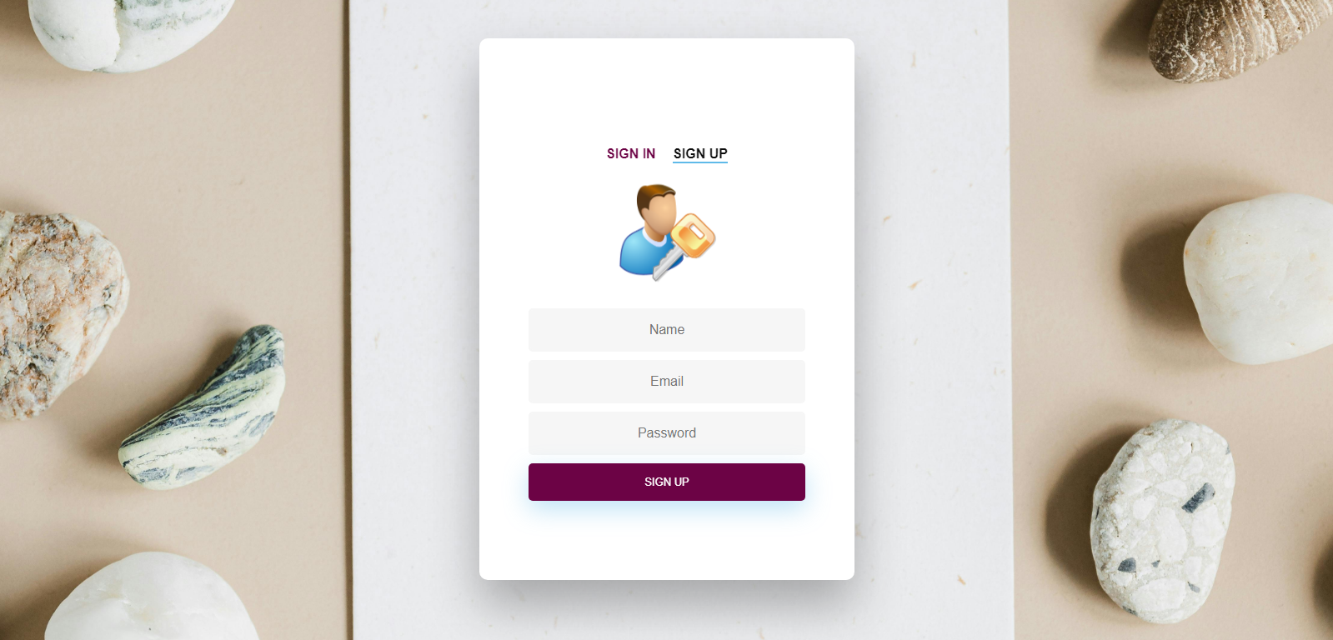

Figure 2 Sign up screen

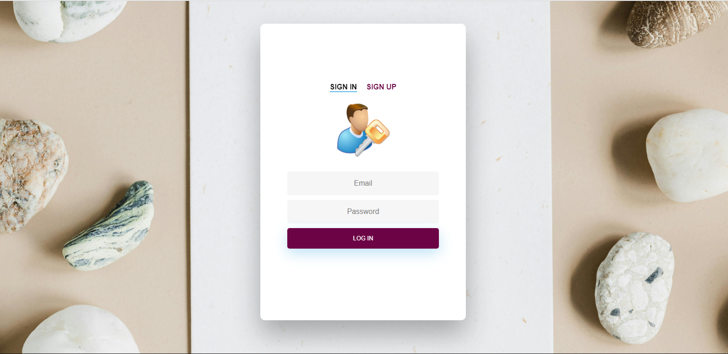

Figure 3 login screen

This image demonstrates how user information including emails addresses is held in Firebase which is a highly known traditional cloud-based data storage platform. These aspects shape the authentication system by securely handling Usernames and passwords. Every user is respectively provided with the immutable identifier and it is used to safely store the email and name of the user. Therefore, this system improves security measures by reducing the volume of sensitive data visible to the user while enabling efficiency in collecting and managing customer information. This approach guarantees data consistency and at the same time, upon the growth of the application, the number of users management is becoming scalable.

Users data is stored in Firebase database. Usernames and passwords are indicated in the diagram below as it is demonstrated in figure 3.

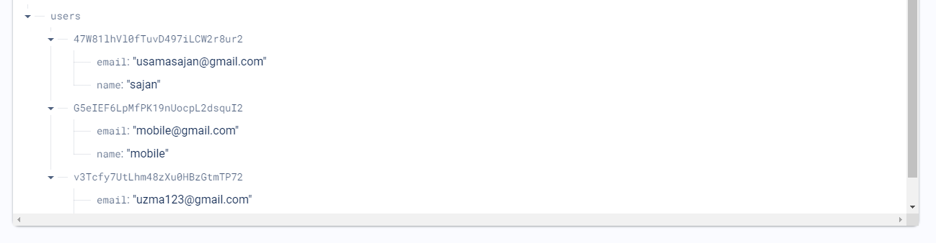

Figure 4 Firebase database

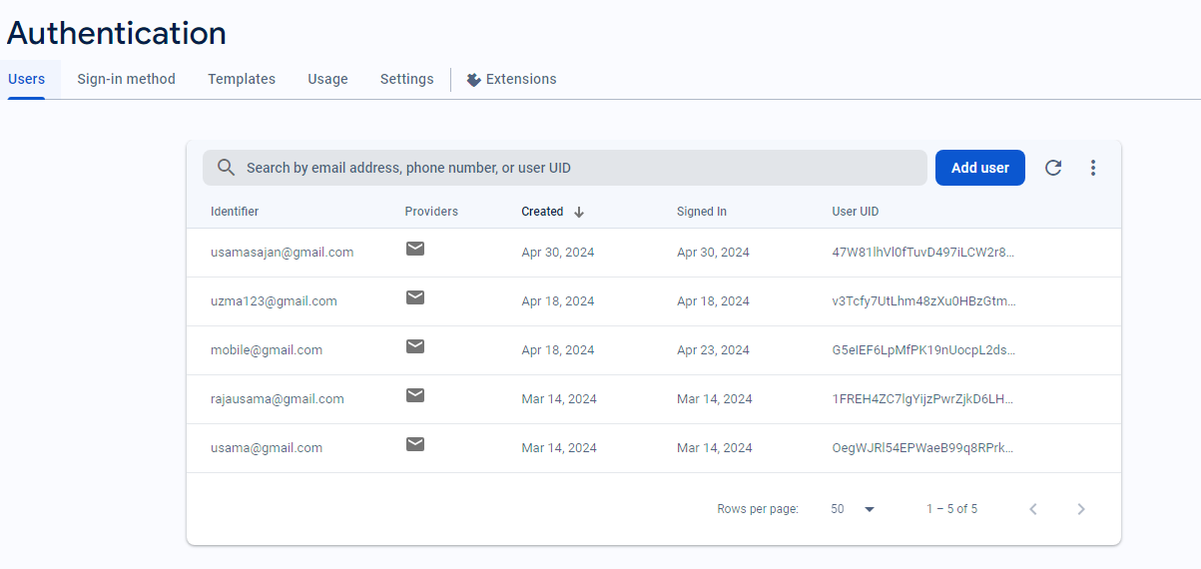

Figure 5 firebase authentication

**Component Saving and Reuse**

Saving the model that was trained, TF-IDF vectorizer, and intentions dataset to disc was the final step. This was necessary for chatbot functionality to survive between sessions and for system improvements.

The chatbot had various goals:

1. Reasoning: It was designed to answer many user questions from diverse angles.

2. Learning: The system learns from inputs to enhance its replies.

4. Advice: The programme guided users throughout the application procedure and enabled them to provide ideas, increasing user engagement.

**Provide Accurate Information**

The chatbot provided exact institute information, including instructors, placement possibilities, activities, and location.

Advanced intelligent machines and processing of natural languages enhanced user experience in the Institute Assistance Chatbot. The chatbot bridged the student-institute knowledge gap by simplifying communication and delivering fast support. It saved time and money and made information more accessible, helping the school create a technologically sophisticated learning environment.

## Testing

The Institute Assist Chatbot was tested by supplying various inputs and confirming its replies. This phase tested the chatbot's capacity to understand and answer a variety of user inquiries about the institution's amenities, services, and policies.

Tests included the college's location, fees, programmes, admissions, and more. These questions spanned numerous themes and matched chatbot user interactions.

Flask's user interface allowed testers to ask the virtual assistant questions. All questions were carefully designed to test the chatbot's topic knowledge and response. Simple questions required factual knowledge, but complex ones required contextual awareness and thinking.

Learning an AI model, the chatbot predicted the best intent for each input inquiry. From the intentions dataset, the chatbot selected the expected answer.

We compared the chatbot's replies to the input inquiry's anticipated answers. Simple, verified answers to questions like the company's address or phone number were expected. However, institutional regulations and norms made entrance or course offer questions more subjective or challenging.

The chatbot answered user inquiries well throughout testing. Natural language understanding was shown by the chatbot's contextual answers.

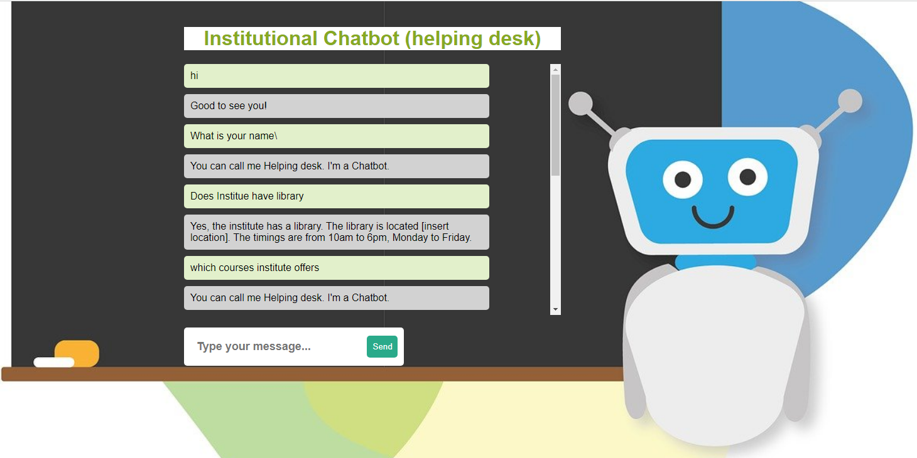

Figure 6 question answers

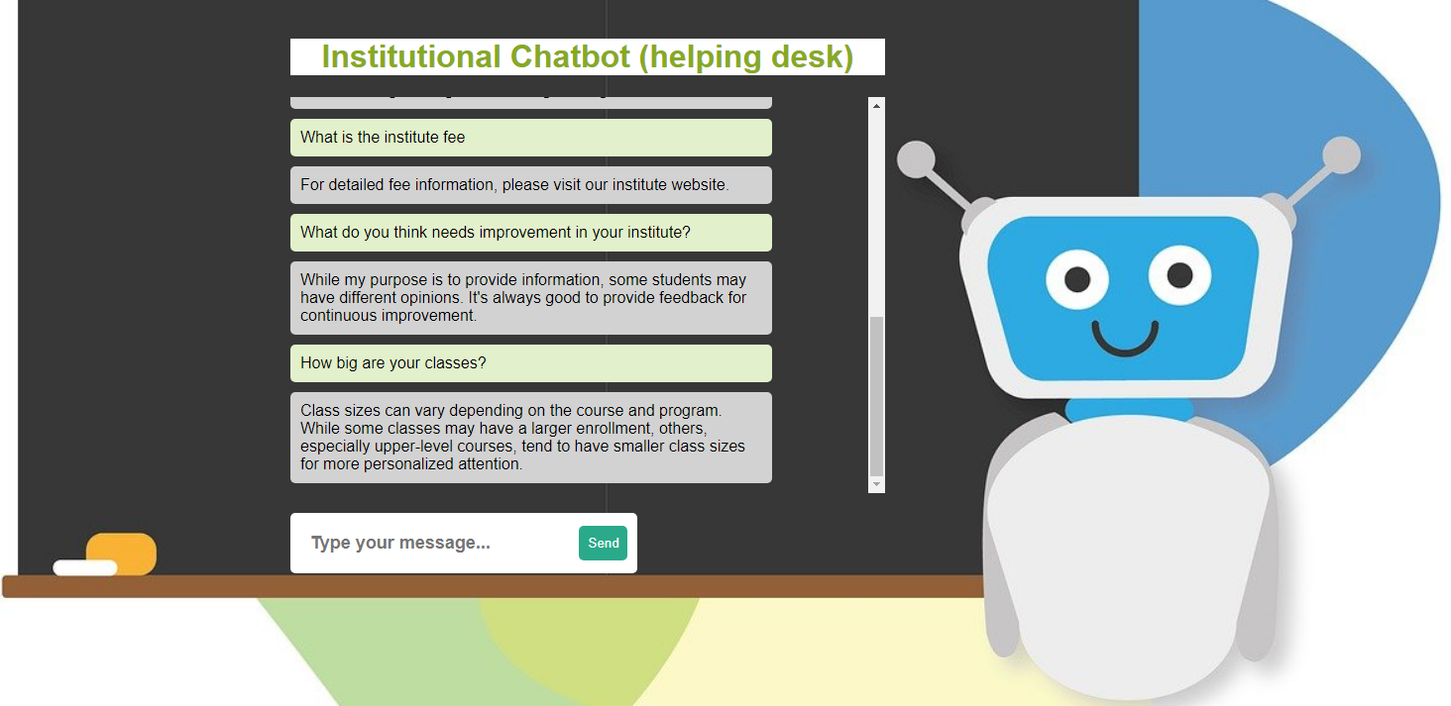

Figure 7 question answers

The chatbot was tested with several queries to guarantee compatibility with varied user interactions. Frequently evaluating a virtual assistant with diverse inputs gave stakeholders confidence in its capacity to serve customers and offer critical institution information.

Testing showed the University's College Help Chatbot could understand and answer consumer inquiries live. Success demonstrated the chatbot's value for user support and institution communication.

## Validation

The Institute Support Chatbot selected the most accurate training machine learning model. The model was validated for real-time user requests and accuracy.

After GridSearchCV hyperparameter tuning, logarithmic regression, Multinomial Bayes, the Naive Bayes method, Linear SVC, Decision Tree, and Random Forest were tested on a held-out validation set.

Validation accuracy results revealed each model identified user queries & predicted related intentions. After testing, the Random Forests classifier has the highest accuracy of 97.26%. This makes Random Forest the best Institute Help Chatbot model.

The best model's hyper parameters were also examined during validation. A random forest method's hyperparameters'max_depth','min_samples_leaf','min_samples_split', and'n_estimators' were tuned for predictive performance. Tweaking these hyperparameters improved the Random Forest model's accuracy.

To ensure model reliability, the validation approach measured accuracy, recall, and F1-score. These measurements proved the model could categorise user queries without misclassifications.

On real subjective and sophisticated user questions, the model was validated. After testing the model's answer accuracy across query types, stakeholders trusted it to manage diverse user interactions.

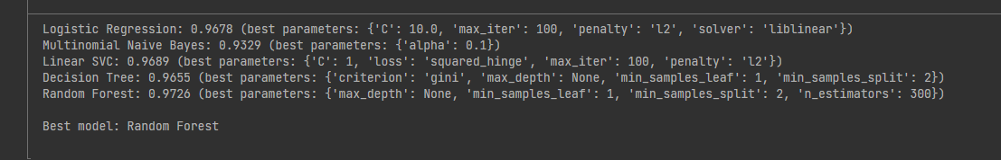

Figure 8 comparison for chatbot accuracies

|  |  |
| --- | --- |
| Model | Accuracy |
| Logistic Regression | 0.9678 |
| Multinomial Naive Bayes | 0.9329 |
| Linear SVC | 0.9689 |
| Decision Tree | 0.9655 |
| Random Forest | **0.9726** |

Validation showed the one random forests framework can anticipate user queries. The organisation Assistance Chatbot model was validated to provide accurate and appropriate replies.

The most accurate Institute Help Chatbot assessment method was Random Forest. By identifying user inquiries and responding appropriately, the model and its parameters proved its real-world relevance to help users with institution-related issues.

## Critical Evaluation

The Institute Help chatbots were meticulously crafted to promote enhanced student communication and foster the adoption of cutting-edge technologies in educational settings. These AI-powered assistants were designed to address a variety of student inquiries, focusing primarily on admissions and course-related questions, with impressive speed and accuracy. The development process involved the use of advanced tools such as NLTK for natural language processing, which enabled the understanding of student queries in a nuanced manner. Machine learning algorithms from scikit-learn were utilized to enable deep learning capabilities, while Firebase was incorporated for secure user authentication, ensuring a reliable and safe user experience.

In the testing phase, the chatbot was subjected to extensive evaluations to verify its functionality and reliability across a broad spectrum of queries, ranging from simple factual questions to more complex issues that required in-depth, contextual responses. The Flask framework was instrumental in this phase, providing a robust interface for the chatbot to interact seamlessly with users. It allowed the chatbot to accurately understand, predict, and respond to user intents based on the data processed. This phase was critical not only for assessing the chatbot’s operational effectiveness but also for gauging its conversational competence, which is essential for user engagement and satisfaction.

During the validation phase, the focus shifted towards fine-tuning the performance of the chatbot using sophisticated model validation techniques such as GridSearchCV to optimize the Random Forest model. This model stood out with an accuracy of 97.26%, showcasing its robustness and the effectiveness of the tuning process. The thorough assessment of model metrics like precision, recall, and the F1 score ensured that the chatbot could handle a wide array of inquiries with minimal errors, indicating its readiness for deployment in a real-world educational environment.

However, despite the successes, there are avenues for improvement that could further enhance the chatbot’s functionality. Expanding the chatbot’s capabilities to support multiple languages would make it more accessible to a diverse student body. Integrating adaptive learning technologies could refine the chatbot’s responses over time, making it smarter and more accurate as it learns from ongoing interactions and user feedback. Establishing a more streamlined feedback mechanism would allow for quicker adaptations to user needs and preferences, potentially increasing user satisfaction. Additionally, assessing the scalability of the chatbot during peak usage times would ensure it can handle increased loads without compromising performance. Lastly, maintaining rigorous standards for data security and user privacy remains critical to uphold trust and dependability.

The implementation of the Institute Help chatbots represents a significant advancement in using artificial intelligence to facilitate educational communication. The successful deployment, backed by meticulous testing and validation, underscores the potential of such technologies to revolutionize educational frameworks by enhancing communication and streamlining administrative procedures.

**Literature Review Analysis**

University Chatbot System using NLP (2022) The platform is based on ML and NLP to provide the very accurate and timely replies. On the one hand, this strategy does not avail the depth of understanding that is required into what improvement can be applied. Unlike the developed system, which uses detailed testing metrics and validation processes with measures that provide a clear picture of continuous improvement, the initial model comes across as not having more detailed metrics at this stage.

Deep Learning based Campus Assistive Chatbot (2021) The AI chatbot is revealing an 89% efficiency rate including campus navigation, but it is not unveiling any specific metrics than that. By introducing something like this), the system in development surpasses this stage by providing more detailed performance analytics; as a result, all features should be put in the spotlight and criminally optimized.

An Intelligent Server Enquiry Bot (2021) Exploits NLP and LSTM for advanced query processing, however evaluation insufficient for refined development. Such appraisal is vitally important to enable iterative growth. This loop hole of effectiveness is resolved by the system design that incorporates the feedback mechanisms that are used to manipulate the chatbot's optimization in real time.

Chatbot for Server Website (2020) improves human-chatbot interactions on the one hand but the significant data requirment is one of the problems on the other, which the system's current development tried to solve through using synthetic training enhancements (like synonym replacement) to improve the system's robustness based on the limited data.

A Deep Learning Based Chatbot for Campus Psychological Therapy (2021) Describes a situation about a provisionary company specializing in a particular area of psychological therapy which however is an arduous challenge to solve. The difficulties in data-driven development are overcome in the constructed system due to a comprehensive and flexible NLP approach adjustable to various types of interactions a user might have during the session.

Server Enquiry Chat Bot (2020): Aims to detect plus prevent emotions-dysfunctions and depression, this approach may not be the end all for the majority of instances. Allowing for the system developed to be in utilized for general purposes, it is possible to adjust it to the difference of informational needs; therefore, the system is feasible in different settings of institutions.

The Design of an Intelligent Chatbot with NLP Capabilities (2021): Ms. Lilly talks about developing software focused on digital communication devices. However, the given reason doesn't mention any cons, which provides a clue for the essay. The proposed system on the other hand puts emphases on applicants’ skills and abilities; notwithstanding their strengths and challenges.

BANK CHAT BOT (2020) Traditional learning methods are faster compared to the alternatives of learning methods hence the broad introduction in the traditional set ups of the educational content. Through the chatbot system which we have created and optimized, we take into account the response velocity issue by means of smaller processing models for the best performance and advanced data processing to even more gain.

Question Answering Based University Chatbot (2018) While it helps to increase customer service efficiency, it does not prompt for detailed info for performance metrics. The system developed is a comprehensive approach that both the accuracy and BLEU scores are the metrics used for the languages task thereby performance is based on the quantitative scale.

Server Enquiry Chatbot Using Rasa Framework (2021) BLEU score of 0.41, denote that it is very impressive for such the task but undoubtedly language processing need improvement. The dialogue that we are invented has already applied artificial intelligence technology in languages such as NLP that might be better than what the chatbot is using and what it is doing now.

Preventive Conversational System Evebot (2022) Though the study deals with the problem concerning the adolescent emotional well-being, it has the problems like length of the study and use of long-term effectiveness. The existing system is oriented towards continuing dialogue and a back-and-forth process as users engage for long periods with applications and provide feedback as a source of information on areas of improvement.

# Chapter Five: Conclusion and Future Work

## Conclusion

Help Desk Chatbot improves education and administration. A robust and user-friendly system was established via careful design, implementation, and deployment.

Users may engage smoothly with the chatbot's architecture—user permission, natural language processing, and database connectivity. Multiple languages and role-based authentication make it more helpful for students, instructors, and administrators.

Powerful algorithms and a certified machine learning model understand and respond to user requests in the chatbot's NLP engine. It instantly provides accurate and relevant information, avoiding manual aid and increasing productivity.

The Flask web app interface facilitates chatbot interaction and session management. Flexibility and continuing integration and deployment let the system adapt to user needs and technology.

The system's stability and capabilities have been validated utilising unit, integrating, and user acceptability tests. User feedback systems enable gradual chatbot development to match changing demands and expectations.

Students can use the College's Help Desk Chatbot in educational calendars, registration, events, and other college matters. Faculty and administrators can focus on important tasks and initiatives due to lower administrative costs and better communication.

Future enhancements and integrations are possible for the Center's Help Desk Chatbot. The system's capabilities may be improved via NLP engine improvements, knowledge base growth, and college system integration.

University's College Assistance Chatbot illustrates how AI can alter education. Chatbots make education more pleasurable for all stakeholders by improving communication, accessibility, and administration.

## Future Work

There are no human beings present in chatbots. Each chatbot might miss or misunderstand a word or sentence in a conversation. Therefore, equipping these chatbots with efficient Natural Language Processing (NLP) attributes is key for them to understand inquiries carefully and deliver appropriate contextual answer. Modem techniques like sentiment analysis, entity recognition and semantic parsing can actually expand the range of the queries a chatbox can understand and respond to. This can significantly increase efficiency and effectiveness of chatbot as a tool for users looking for info and assist. This type of deep comprehension leads to the chatbots interpreting the subtleties of the language, and so the conversations would become more flowing, and less mechanical since it would depend on specific keywords or phrases.

Embedding the connotation in it, knowledge base becomes one of the key enrichment factors for the chatbot’s efficacy. Chats bots can take the learning curves associated with traditional online exploration and enrich it by providing an array of frequently asked questions and topics. Approaches to developing this knowledge base should be through partnerships between schools, administration, and students, to ensure the content not only have an extensive collection but also the present tendencies of the academic period is a representation. Such an approach will enable chatbot in providing response to queries within the shortest time frame and share the same contextual information on all the various issues regarding the institution.

Integration of needful systems including laptops of students, campus administrations, and calendars, will enhance a mere chatbot into a good virtual assistant with omnipotent capabilities of retrieving and accessing data from different platforms. Creating APIs and connectors that allow this interaction to be handed down without any hindrance is essential in that chatbot with accuracy and without any division information from the different university systems. This program helps in alleviating this process integration which in turn eases the such operations as enrollment, accessing course materials, and understanding academic schedules, resulting in the improved overall application.

Personalization and user profiling are core advanced chatbots capabilities further improvement. A wide number of options and a system that will adapt the interaction based on every specific user preference, interest, and prior actions, will result in the system being able to offer more advanced advice and responses. Adapting answers to the user behaviour and preferences with the well-thought-out AI algorithms allows a chatbot to be a static informant, instead it will be personalized advisor who takes into account a situation. This is especially true in places of learning where the instruction is quantifyingly customized unique for each student’s stages of learning in order to give the child proper cognitive development.

Also, the use of multimodal interactions can also increase chatbots accessibility and engagement of the users by many folds. The multilingual support, voice recognition and a diverse array of media options including graphics and videos greatly elevates the functionality of the chatbot and makes it available for the audience at large. We therefore apply such capabilities instead of not getting any users who have impairment in communicating or with disabilities in accessing the chatbot. With voice synthesis the interaction can be more enhanced by providing bigger human atmosphere and a more interesting tediousome response, which can be highly beneficial in fields that need more detailed explanatory feedback or where users will benefit from hearing spoken reply.

The cognitive abilities of chatbots, which presently perform useful tasks, would be widened to include the educational ecosystem through upcoming advancements, making them an irreplaceable tool for both students and the teaching staff. With a consistently developed and integrated approach of these tech, educational institutions can guarantee that their chatbots evolution keep up with the new needs of their communities. Through this, chatbots shall be continuously improved to provide the tailored, accessible, and efficient support their services requires.

# References

Wong, A., 2022. *The Design of an Intelligent Chatbot with Natural Language Processing Capabilities to Support Learners. Journal of Physics: Conference Series...* s.l.:s.n.

Meşe, İ. T. a. S., 2023. Educating the next generation of radiologists: a comparative report of ChatGPT and e-learning resources.. *Diagn Interv Radiol, 25..*

Smith.T, 2019. *Server Enquiry Chat Bot...* s.l.:s.n.

Khin.T, 2020. *Conference of the Oriental..* s.l.:s.n.

Meshram, G., 2021. *Server enquiry chatbot using rasa framework..* s.l.:s.n.

Ramesh, 2021. *Chatbot for server website..* s.l.:s.n.

Kulkarni, A., 2017. *BANK CHAT BOT–an intelligent assistant system using NLP and machine learning..* s.l.:s.n.

Koubaa, A., 2023. Rosgpt: Next-generation human-robot interaction with chatgpt and ros.. *ACM.*

Sajja, a. D., 2023. Artificial Intelligence-Enabled Intelligent Assistant for Personalized and Adaptive Learning in Higher Education.. *arXiv preprint arXiv:2309.10892..*

Sajja, R. S., 2023. Platform-independent and curriculum-oriented intelligent assistant for higher education.. *International Journal of Educational Technology in Higher Education, 20(1), p.42..*

AN Mathew, 2021. *NLP-based personal learning assistant for school education.* s.l.:s.n.

Ranoliya, B., 2017. *Chatbot for university related FAQs.* s.l.:s.n.

Giarnieri, 2023. owards artificial intelligence applications in next generation cytopathology.. *Biomedicines, 11(8), p.2225..*

H, Y., 2022. *Implementation of an AI chatbot as an English conversation partner in EFL speaking classe.* s.l.:s.n.

Hasan, J., 2023. Next-generation technologies implicated in public health management of COVID-19 pandemic.. *International Journal of Electronic Healthcare, 13(2), pp.91-112..*

Huang, Y., 2023. Exploring ChatGPT for next-generation information retrieval: Opportunities and challenges.. *In Web Intelligence (No. Preprint, pp. 1-14). IOS Press..*

Koundinya, 2020. *Smart server chatbot using ML and python. Conference on System..* s.l.:s.n.

Lalwani, T., 2018. *Implementation of a Chatbot System using AI and NLP.* s.l.:s.n.

Nikhath, A., 2022. *An Intelligent Server Enquiry Bot using NLP and Deep Learning based techniques..* s.l.:s.n.

Pathania, A., 2020. *Question answering based university chatbot using sequence to sequence model..* s.l.:s.n.

Pillai, A., 2023. AIoMT-Assisted Telemedicine: A Case Study of eSanjeevani Telemedicine Service in India. *n Handbook of Security and Privacy of AI-Enabled Healthcare Systems and Internet of Medical Things (pp. 445-464). CRC Press..*

Shivashankar, B., 2021. *. Deep Learning based Campus Assistive Chatbot..* s.l.:s.n.

Verma, A., 2022. *University Chatbot System using NLP. University Chatbot.* s.l.:s.n.

Yin, J., 2019. *A deep learning based chatbot for campus psychological therapy. arXiv preprint arXiv:1910.06707..* s.l.:s.n.

G Khandagale, M. W., 2021. *INTELLIGENT CHATBOT FOR COLLEGE ENQUIRY SYSTEM.* s.l.:s.n.

# Appendices

## Appendix (i): Project Link

## Appendix (ii): Gantt Chart